**Test Cases**

| **Input** | **Expected Output** | **Actual** **Output** | **Pass?** |
| --- | --- | --- | --- |
| Name=Gabriel Harper  L1=10 L2=20 L3=30 ES=40  Name=Luca Hunter L1=15 L2=25 L3=35 ES=45 | Gamer Name: Gabriel Harper L1=10 L2=20 L3=30 ES=40  Final XP score with bonuses=147.0  Gamer Name: Luca Hunter L1=15 L2=25 L3=35 ES=45  Final XP score with bonuses=175.0 | Gamer Name: Gabriel Harper L1=10 L2=20 L3=30 ES=40  Final XP score with bonuses=147.0  Gamer Name: Luca Hunter L1=15 L2=25 L3=35 ES=45  Final XP score with bonuses=175.0 | YES |
| Name=Ollie Owen  L1=90 L2=90 L3=80 ES=80  Name=Alex Stevens L1=15 L2=25 L3=35 ES=45 | Gamer Name: Ollie Owen L1=90 L2=90 L3=80 ES=80  Final XP score with bonuses=473.0  Gamer Name: Alex Stevens L1=75 L2=65 L3=80 ES=45  Final XP score with bonuses=366.5 | Gamer Name: Ollie Owen L1=90 L2=90 L3=80 ES=80  Final XP score with bonuses=473.0  Gamer Name: Alex Stevens L1=75 L2=65 L3=80 ES=45  Final XP score with bonuses=366.5 | YES |
| Name=Jackson Harris  L1=5 L2=45 L3=90 ES=85  Name=Jalen Galloway L1=17 L2=80 L3=90 ES=45 | Score input should be in whole numbers between 10-100  Score input should be in whole numbers in increments of 5 | Score input should be in whole numbers between 10-100  Score input should be in whole numbers in increments of 5 | YES |
| Exit program without inputting gamer’s data | Thank you for using the Total XP calculation program! | Thank you for using the Total XP calculation program! | YES |

**Screen Capture**

**Test Case 1:**

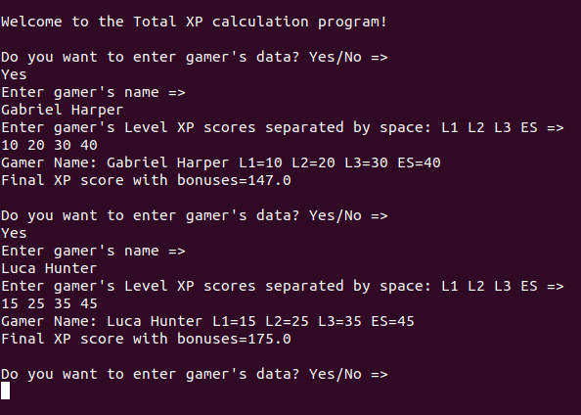

**Test Case 2:**

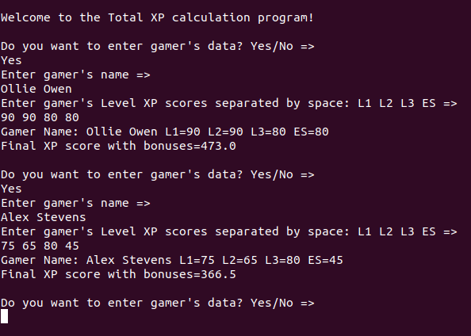

**Test Case 3:**

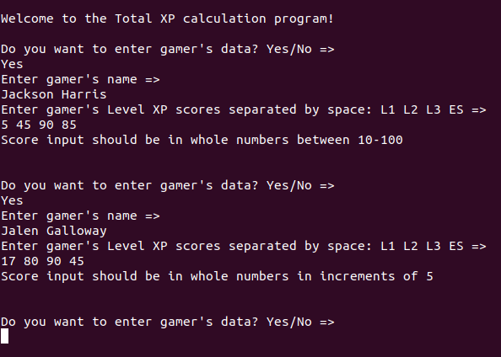

**Test Case 4:**

